Date
# Source: AI Source: Provided by: [Data Path: Persons Table -> ID Column: 1, Name_En Column: Motasem Essam] -> From: [ChatGPT] on [7/17/2026]
A Date is a measurement of time that identifies a specific day within a calendar system. It enables people to organize events, record history, schedule activities, and calculate time intervals.
Dates are used worldwide in education, science, business, government, medicine, transportation, computing, and everyday life.

Definition
# Source: AI Source: Provided by: [Data Path: Persons Table -> ID Column: 1, Name_En Column: Motasem Essam] -> From: [ChatGPT] on [7/17/2026]
A Date is a standardized representation of a specific day within a calendar system, typically expressed using the day, month, and year.

Purpose
# Source: AI Source: Provided by: [Data Path: Persons Table -> ID Column: 1, Name_En Column: Motasem Essam] -> From: [ChatGPT] on [7/17/2026]
Dates are used to:
- Identify a specific day.
- Record historical events.
- Schedule appointments.
- Plan future activities.
- Calculate age and duration.
- Track deadlines.
- Organize records and databases.

Basic Components of a Date
# Source: AI Source: Provided by: [Data Path: Persons Table -> ID Column: 1, Name_En Column: Motasem Essam] -> From: [ChatGPT] on [7/17/2026]
A complete date usually consists of:
- Day
- Month
- Year
Example:
25 April 2026
Where:
- Day = 25
- Month = April
- Year = 2026

Common Date Formats
# Source: AI Source: Provided by: [Data Path: Persons Table -> ID Column: 1, Name_En Column: Motasem Essam] -> From: [ChatGPT] on [7/17/2026]
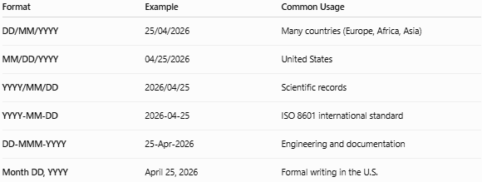
Format | Example | Common Usage
DD/MM/YYYY | 25/04/2026 | Many countries (Europe, Africa, Asia)
MM/DD/YYYY | 04/25/2026 | United States
YYYY/MM/DD | 2026/04/25 | Scientific records
YYYY-MM-DD | 2026-04-25 | ISO 8601 international standard
DD-MMM-YYYY | 25-Apr-2026 | Engineering and documentation
Month DD, YYYY | April 25, 2026 | Formal writing in the U.S.

Types of Dates

1. Calendar Date
# Source: AI Source: Provided by: [Data Path: Persons Table -> ID Column: 1, Name_En Column: Motasem Essam] -> From: [ChatGPT] on [7/17/2026]
The standard civil date used in everyday life.
Example:
- 25 April 2026
Applications:
- Birthdays
- Meetings
- School schedules

2. Historical Date
# Source: AI Source: Provided by: [Data Path: Persons Table -> ID Column: 1, Name_En Column: Motasem Essam] -> From: [ChatGPT] on [7/17/2026]
Used to record important historical events.
Examples:
- 20 July 1969 (Apollo 11 Moon landing)
- 4 July 1776 (U.S. Declaration of Independence)
Applications:
- History
- Museums
- Archives

3. Fiscal Date
# Source: AI Source: Provided by: [Data Path: Persons Table -> ID Column: 1, Name_En Column: Motasem Essam] -> From: [ChatGPT] on [7/17/2026]
Used in accounting and finance according to a fiscal year rather than a calendar year.
Example:
- Fiscal Year 2026
Applications:
- Accounting
- Government
- Business

4. Manufacturing Date (MFG)
# Source: AI Source: Provided by: [Data Path: Persons Table -> ID Column: 1, Name_En Column: Motasem Essam] -> From: [ChatGPT] on [7/17/2026]
Indicates when a product was manufactured.
Example:
- MFG: 15/02/2026
Applications:
- Food
- Pharmaceuticals
- Manufacturing

5. Expiration Date (EXP)
# Source: AI Source: Provided by: [Data Path: Persons Table -> ID Column: 1, Name_En Column: Motasem Essam] -> From: [ChatGPT] on [7/17/2026]
Indicates the last recommended date for safe or effective use.
Example:
- EXP: 15/02/2028
Applications:
- Food products
- Medicines
- Cosmetics

6. Due Date
# Source: AI Source: Provided by: [Data Path: Persons Table -> ID Column: 1, Name_En Column: Motasem Essam] -> From: [ChatGPT] on [7/17/2026]
The date by which a task or payment should be completed.
Examples:
- Assignment due date
- Loan payment due date
Applications:
- Education
- Finance
- Business

7. Issue Date
# Source: AI Source: Provided by: [Data Path: Persons Table -> ID Column: 1, Name_En Column: Motasem Essam] -> From: [ChatGPT] on [7/17/2026]
The date on which a document was officially created or released.
Examples:
- Passport issue date
- Invoice issue date
- Certificate issue date

8. Effective Date
# Source: AI Source: Provided by: [Data Path: Persons Table -> ID Column: 1, Name_En Column: Motasem Essam] -> From: [ChatGPT] on [7/17/2026]
The date on which a contract, law, or policy becomes active.
Applications:
- Legal documents
- Employment contracts
- Insurance policies

9. Revision Date
# Source: AI Source: Provided by: [Data Path: Persons Table -> ID Column: 1, Name_En Column: Motasem Essam] -> From: [ChatGPT] on [7/17/2026]
The date a document or drawing was updated.
Applications:
- Engineering drawings
- Technical manuals
- Standards documentation

10. Timestamp
# Source: AI Source: Provided by: [Data Path: Persons Table -> ID Column: 1, Name_En Column: Motasem Essam] -> From: [ChatGPT] on [7/17/2026]
A date combined with the exact time.
Example:
- 2026-04-25 14:30:45
Applications:
- Databases
- Computer systems
- Security logs
- Programming

Date Representation Standards
# Source: AI Source: Provided by: [Data Path: Persons Table -> ID Column: 1, Name_En Column: Motasem Essam] -> From: [ChatGPT] on [7/17/2026]
ISO 8601
International standard:
YYYY-MM-DD
Example:
- 2026-04-25
Advantages:
- Eliminates ambiguity.
- Sorts chronologically.
- Widely used in computing.

Months of the Year
# Source: AI Source: Provided by: [Data Path: Persons Table -> ID Column: 1, Name_En Column: Motasem Essam] -> From: [ChatGPT] on [7/17/2026]
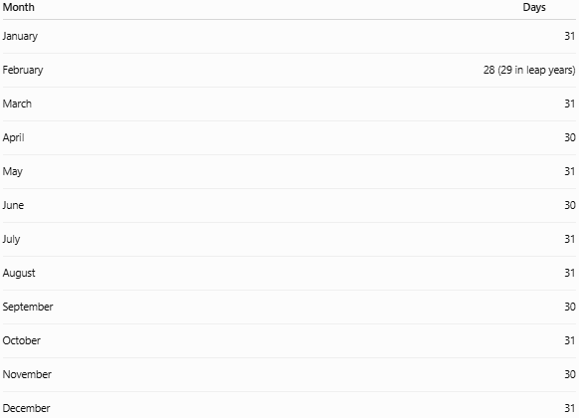
Month | Days
January | 31
February | 28 (29 in leap years)
March | 31
April | 30
May | 31
June | 30
July | 31
August | 31
September | 30
October | 31
November | 30
December | 31

Leap Year
# Source: AI Source: Provided by: [Data Path: Persons Table -> ID Column: 1, Name_En Column: Motasem Essam] -> From: [ChatGPT] on [7/17/2026]
A Leap Year contains 366 days instead of 365.
February has:
- 28 days (normal year)
- 29 days (leap year)
A year is generally a leap year if:
- It is divisible by 4,
- Except years divisible by 100, unless they are also divisible by 400.
Examples:
- 2024 ✔
- 2028 ✔
- 2100 ✘
- 2000 ✔

Date Calculations
# Source: AI Source: Provided by: [Data Path: Persons Table -> ID Column: 1, Name_En Column: Motasem Essam] -> From: [ChatGPT] on [7/17/2026]
Common operations include:
- Finding age
- Calculating duration
- Counting days between dates
- Determining weekdays
- Scheduling future dates
Example:
25 April 2026 → 5 days later = 30 April 2026

Applications
# Source: AI Source: Provided by: [Data Path: Persons Table -> ID Column: 1, Name_En Column: Motasem Essam] -> From: [ChatGPT] on [7/17/2026]
Dates are used in:
- Education
- Banking
- Healthcare
- Manufacturing
- Government
- Transportation
- Computer systems
- Scientific research
- Legal documentation

Advantages of Standardized Dates
# Source: AI Source: Provided by: [Data Path: Persons Table -> ID Column: 1, Name_En Column: Motasem Essam] -> From: [ChatGPT] on [7/17/2026]
Standardized date formats:
- Improve communication.
- Reduce ambiguity.
- Simplify international data exchange.
- Support accurate record keeping.
- Facilitate computer processing.

Common Mistakes
# Source: AI Source: Provided by: [Data Path: Persons Table -> ID Column: 1, Name_En Column: Motasem Essam] -> From: [ChatGPT] on [7/17/2026]
- Confusing DD/MM/YYYY with MM/DD/YYYY.
- Forgetting leap years.
- Using inconsistent formats in the same document.
- Omitting the year when long-term clarity is required.
- Misinterpreting ambiguous numeric dates (e.g., 04/05/2026).

Key Points
# Source: AI Source: Provided by: [Data Path: Persons Table -> ID Column: 1, Name_En Column: Motasem Essam] -> From: [ChatGPT] on [7/17/2026]
- A Date identifies a specific day within a calendar system.
- It is composed of day, month, and year.
- Common types include:
  - Calendar Date
  - Historical Date
  - Fiscal Date
  - Manufacturing Date
  - Expiration Date
  - Due Date
  - Issue Date
  - Effective Date
  - Revision Date
  - Timestamp
- ISO 8601 (YYYY-MM-DD) is the internationally recognized standard for unambiguous date representation.

Conclusion
# Source: AI Source: Provided by: [Data Path: Persons Table -> ID Column: 1, Name_En Column: Motasem Essam] -> From: [ChatGPT] on [7/17/2026]
A Date is a fundamental method of measuring time that identifies a specific day within a calendar system. Different types of dates serve specialized purposes in fields such as history, manufacturing, business, law, healthcare, and computing. Using standardized date formats—especially ISO 8601—helps ensure consistency, reduces ambiguity, and supports reliable communication and data management across different countries and industries.

